HYPOGYMNIA (Nyl.) Nyl. v.2025
17 Species/subspecies recorded in Alberta
austerodes group (Nyl.) Räsänen Syn.: Parmelia austerodes ACIMS, ABMI
austerodes sensu stricto (Nyl.) Räsänen – See Goward et al. 2012 for recent split to 5 spp.
dichroma Goward
protea Goward, T. Sprib. & Ahti
salsa Goward
verruculosa Goward
bitteri (Lynge) Ahti Syn.: Parmelia bitteri ACIMS, ABMI
duplicata (Ach.) Rass. ACIMS
enteromorpha (Ach.) Nyl. ACIMS, ABMI
imshaugii Krog ACIMS
inactiva (Krog) Ohlsson ACIMS
occidentalis L. Pike ACIMS
physodes (L.) Nyl. Syns.: Parmelia duplicata var. douglasicola, P. physodes, P. oregana ACIMS, ABMI
rugosa (G. Merr.) L. Pike ACIMS
subobscura (Vainio) Poelt Syn.: Parmelia subobscura ACIMS
tubulosa (Schaerer) Hav. Syn.: Parmelia tubulosa ACIMS, ABMI
vittata (Ach.) Parrique Syn.: Parmelia vittata ACIMS
wilfiana Goward, T. Sprib. & Ahti Western NA (Goward et al. 2010) Prev. misided as H. metaphysodes

DICHOTOMOUS KEY – Hypogymnia
Slightly modified from Goward et al. 1994, Goward et al. 2012, with input from Brodo et al. 2001 and McCune and Geiser 2009
Line drawings from Goward et al. 1994

1a. Soredia present (check lobe tips) 2
2a. Soredia located on inner surface of burst lobe tips Lead 3 – Physodes grp
2b. Soredia located on upper surface (including upper surface of lobe tips)
Lead 4 - Austerodes grp
1b. Soredia absent………………………………………………………………………………………………13
13a. Medullary ceiling distinctly dark almost throughout Lead 14 – Esorediate, dark ceiling
13b. Medullary ceiling mostly white (or at least not distinctly dark: check toward thallus centre and avoid checking near tears in lobes) Lead 19 – Esorediate, pale ceiling

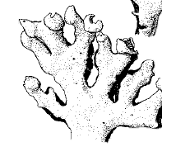
Physodes group – soralia on inner surface of burst lobe tips *No perforations should be present – if lobe tips perforated, see McCune et al. 2006 for more inclusive key
3a. Upper surface usually partly brownish; lobules common, arising from lobes at 90 degree angle; medullary ceiling darkening toward thallus centre; medulla PD-; humid localities H. vittata
3b. Upper surface not at all brownish; medullary ceiling white throughout (rarely darkening); lobes branching repeatedly in acute, dichotomous pattern; medulla PD+ orange; widespread H. physodes→

Austerodes group & H. tubulosa – soralia on margins or laminal on lobes
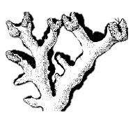
*For H. salsa, protea, dichroma and verruculosa, if a specimen cannot be confidently attributed to one of these species, list as H. austerodes group.
4a. Lobes stiffly suberect, elongate, typically dichotomously branched and ending in two relatively short lobes; upper surface convex; soralia located on or very near lobe tips; widespread H. tubulosa→
4b. Not as above 5

5a. Thallus loosely attached or in part trailing; second-tier lobes often in part forming thallus periphery 6
5b. Thallus more or less closely appressed; second-tier lobes rarely if ever forming the thallus periphery (Note: specimens with isidia and/or gymnidia key here) 8

6a. Upper surface minutely roughened (check thallus centre), usually bearing at least some tiny hemispheric papillae; well-developed marginal soralopodia (=small secondary lobes with laminal soralia) often present at the tips of short, stiff, non-tapering lobes; second-tier lobes stiff, not trailing H. salsa
6b. Upper surface more or less smooth throughout, or at any rate not roughened, usually without papillae; soralopodia sparse to abundant, but scarcely if at all well developed at tips of short, stiff, non-tapering marginal lobes; second-tier lobes usually trailing; widespread 7

7a. Laminal soralia present, usually closely spaced, more or less protuberant; soralopodia usually numerous, conspicuous, the largest ones 0.4–0.8 mm across; eroded lobe tips rarely opening into thallus interior; stress cracks at most few and inconspicuous H. protea morph disjuncta
7b. Laminal soralia absent or, if present, then usually sparse, scarcely elevated above the cortical surface; soralopodia absent or, if present, usually rather inconspicuous, the largest ones 0.2–0.3 mm across; eroded lobe tips, if present, often opening into thallus interior; stress cracks often numerous and conspicuous (check near thallus centre) H. protea morph tessellata

8a. Soralopodia well developed at or near lobe tips, the largest ones usually more than 2 mm across, disintegrating above into coarse cortidia up to 50–80 μm across (check recently formed soralopodia)
H. bitteri
8b. Soralopodia absent or at most poorly developed and small, less than 1 mm across, usually exfoliating, not giving rise to cortidia 9

9a. Upper surface bearing at least some granular or elongate isidia and/or gymnidia (check depressions) (Note: specimens with eroded lobe tips opening into the thallus interior key here) 10
9b. Upper surface without isidia and/or gymnidia 11

10a. First-tier lobes up to 3–4 (–6) mm wide, more or less contiguous, usually entirely obscuring the underlying substrate; thallus usually without isidia-like lobules along the lobe margins
H. austerodes morph austerodes (= s. str.)
10b. First-tier lobes up to 1.5–2.0 (–2.5) mm wide, rather sparsely branched, usually not entirely obscuring the underlying substrate; thallus usually bearing at least some isidia-like lobules along the lobe margins H. austerodes morph depauperata

11a. Upper surface pale greenish, without black mottling; cortex conspicuously brittle, soon dissociating from the underlying medulla, forming exfoliation ridges, cortical flaps and/or coarse cortidia up to 60–80 μm across; soredia present or absent; temperate to low boreal, not definitely known from North America H. farinacea
11b. Upper surface pale greenish to more often brownish, flecked with irregular black mottling; cortex not conspicuously brittle, not dissociating from the medulla, lacking exfoliation ridges and cortical flaps, but sometimes bearing coarse cortidia; soredia present; distribution various 12

12a. First-tier lobes up to 3.5–4.0 (–6.0) mm wide, generally distinctly thickened at the tips; laminal soredia arising through dissolution of granular cortidia up to 50–90 μm across; upper surface variously colored but not whitish toward the thallus centre H. verruculosa
12b. First-tier lobes up to 2–3 (–3.5) mm wide, scarcely if at all swollen at the tips; laminal soredia arising directly from dissolution of the cortex, at most up to only 30–40 μm across; upper surface usually becoming whitish toward the thallus centre H. dichroma

Lead 14 – Esorediate, medullary ceiling distinctly dark almost throughout
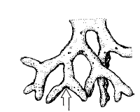
14a. Lobes usually ascending; lobe tips mostly tapered and broadly pointed; perforations absent or restricted to lower surface 15
14b. Lobes appressed or pendulous; lobe tips mostly hemispherical, perforate or not 16

15a. Lobes evenly fork-branching/dichotomous, not strongly and irregularly side-branched; medulla PD- H. inactiva→
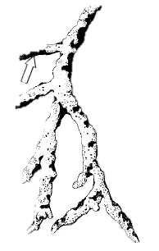
15b. Lobes strongly and irregularly side-branched; medulla PD+ yellow becoming bright orange
H. heterophylla→

16a. Basally constricted marginal lobules sparse or more often absent; medulla PD- or PD+ pale yellow 17
16b. Basally constricted marginal lobules ±abundant; medulla PD- or PD+ yellow becoming bright orange 19

17a. Lobes commonly perforate at tips; upper surface smooth or weakly wrinkled toward thallus centre; lobes short or long, longest usually somewhat “knobby” (i.e., swollen at regular intervals); medulla PD
- H. apinnata
17b. Lobes usually lacking perforations; medulla PD+ pale yellow throughout; apothecia common 18

18a. Upper surface strongly wrinkled toward thallus centre; lobes swollen, generally short, never knobby (Note: Brodo et al. 2001 describe as PD-); medulla K-, KC+ pink H. rugosa
18b. Upper surface at most weakly wrinkled; lobes plane; medulla K+ slow reddish (wait 5 minutes), KC+ orange to red H. canadensis

19a. Lobes averaging to 1.5–2.5 (–3.5) mm across, never knobby; medulla PD-; cortical perforations c+ ommon at branching points of terminal lobes H. occidentalis
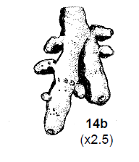
19b. Lobes averaging to 3–4 mm across, longest ones often weakly knobby; medulla PD+ yellow-orange, occasionally PD- H. enteromorpha→

Lead 20 – Esorediate, medullary ceiling mostly white (or at least not distinctly dark: check toward thallus centre; may be dark near tears in thallus)
20a. Upper surface dark brownish, particularly at lobe tips; apothecia absent, PD- 21
20b. Upper surface pale brownish or more often whitish to bluish grey; lobules, if present, along margins; isidia absent; over bark and wood; apothecia common in species with lobes >2mm wide; PD+ or - 22

21a. Usually bearing lobules and/or isidia; over soil and mossy rock; alpine; medulla K+ yellow
H. subobscura
21b. Lacking vegetative propagules; over bark or wood; surface typically with black mottling; medulla K+ reddish brown after 5 minutes esorediate, immature H. austerodes group

22a. Medulla PD-; apothecia common 23
22b. Medulla PD+ yellow becoming orange; apothecia common or not 24

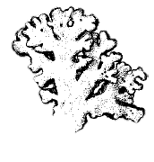
23a. Lobes loosely appressed to trailing with conspicuously upturned lobe tips, 1-3 (-8) mm wide, scarcely branching; thallus papery and pliant; upper surface with greenish cast, plane or concave at lobe tips, convex towards centre of thallus; pycnidia sparse to abundant at lobe tips, resorbed towards thallus centre leaving black pits; apothecia stalked, stalk broadest at base tapering to pale brown disk; with vitatollic acid (TLC) H. recurva
23b. Lobes typically appressed, <2 mm mm wide, branching copiously; thallus brittle and glassy; upper surface plane to weakly concave at lobe tips, often with bluish cast; pycnidia sparse to abundant at lobe tips, may be many brown incipient pycnidia, resorbed towards thallus centre leaving papillae not pits; apothecia stalked, stalk broadest at apex, tapering to base; with apinnatic acid (TLC) H. wilfiana→
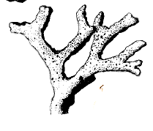
24a. Upper surface often brownish; lobes typically raised and rather stiff; lower surface not much expanded, scarcely visible from above; apothecia common H. imshaugii→
24b. Upper surface whitish; lobes not as above; apothecia rare 25

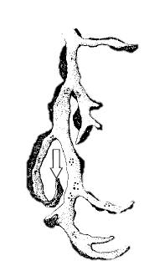
25a. Lobes distinctly pendent (except turned up at tips), >1 mm wide; lower surface often much expanded and clearly visible from above H. duplicata→
25b. Lobes loosely attached, lower surface scarcely visible from above; pycnidia sparse or absent esorediate, immature H. physodes

